Hello Seneca East Cross Country Alumni:

The cross country teams would like to welcome you to the 2019 cross country season! The season that lies ahead will certainly be a year full of fun and excitement as the teams look to carry on the tradition and standard of excellence set by you, the alumni. This season numbers continue to stay high as there are over 50 boys and girls in grades 7-12. This year’s boys team looks to have a strong pack of runners who will have to use a team approach to help them be successful and move their pack up in races as the season goes on. The girls, fresh off a 2018 league championship, will face some challenges as only 2 of the top 7 runners from last year’s team return. Gaining experience and learning throughout the season will be key. Both the boys and girls junior high teams are loaded with talent and have a bright future ahead of them as they are expected to place well throughout the year.

For those of you who attended the special edition, 50th Season Alumni Event, we hope you enjoyed yourself! It is our goal to host this event each and every year in efforts to connect the past with the present! Additionally, the cross country program is also preparing to host the 7th running of “The” Tiger Classic, our home meet, on August 24th. In its first six years, the invitational has grown from 18 teams (year one), all the way to 68 teams this year! It has quickly become a premiere event in the state, and it receives statewide attention as many top teams in the state travel to Seneca East the first Saturday of every season. This is also the 7th year in a row Seneca East will be hosting the league championship meet! This provides the athletes with a great chance to see how much they improved from week one to the league meet as they get to run the same course!

Below is our 2019 schedule! Thank you all for the continued support! We look forward to representing SECC in a positive manner and seeing all of you at the course!

**2019 Cross Country Meet Schedule**

**August 24 -** “The” Tiger Classic @ Seneca East

**August 31 -** @ Bucyrus Invite @ Crawford Co. Fairgrounds

**September 7 -** @ Tiffin Carnival @ Hedges Boyer Park

**September 14 -** @ Galion CC Festival @ Galion Amann’s Park

**September 21 -** @ Fremont St. Joe Invite @ Walsh Park

**September 28 -** Old Fort Invitational @ Old Fort School

**October 4-6-** Team Trip to Chicago, IL

**October 12 -** N-10 League Championships @ Seneca East

**October 19 -** District Championships @ Galion Amann’s Park

**October 26 -** Regional Championships @ Tiffin Hedges Boyer

**November 2 -** State Championships @ National Trail-Hebron

**“TRADITION”**

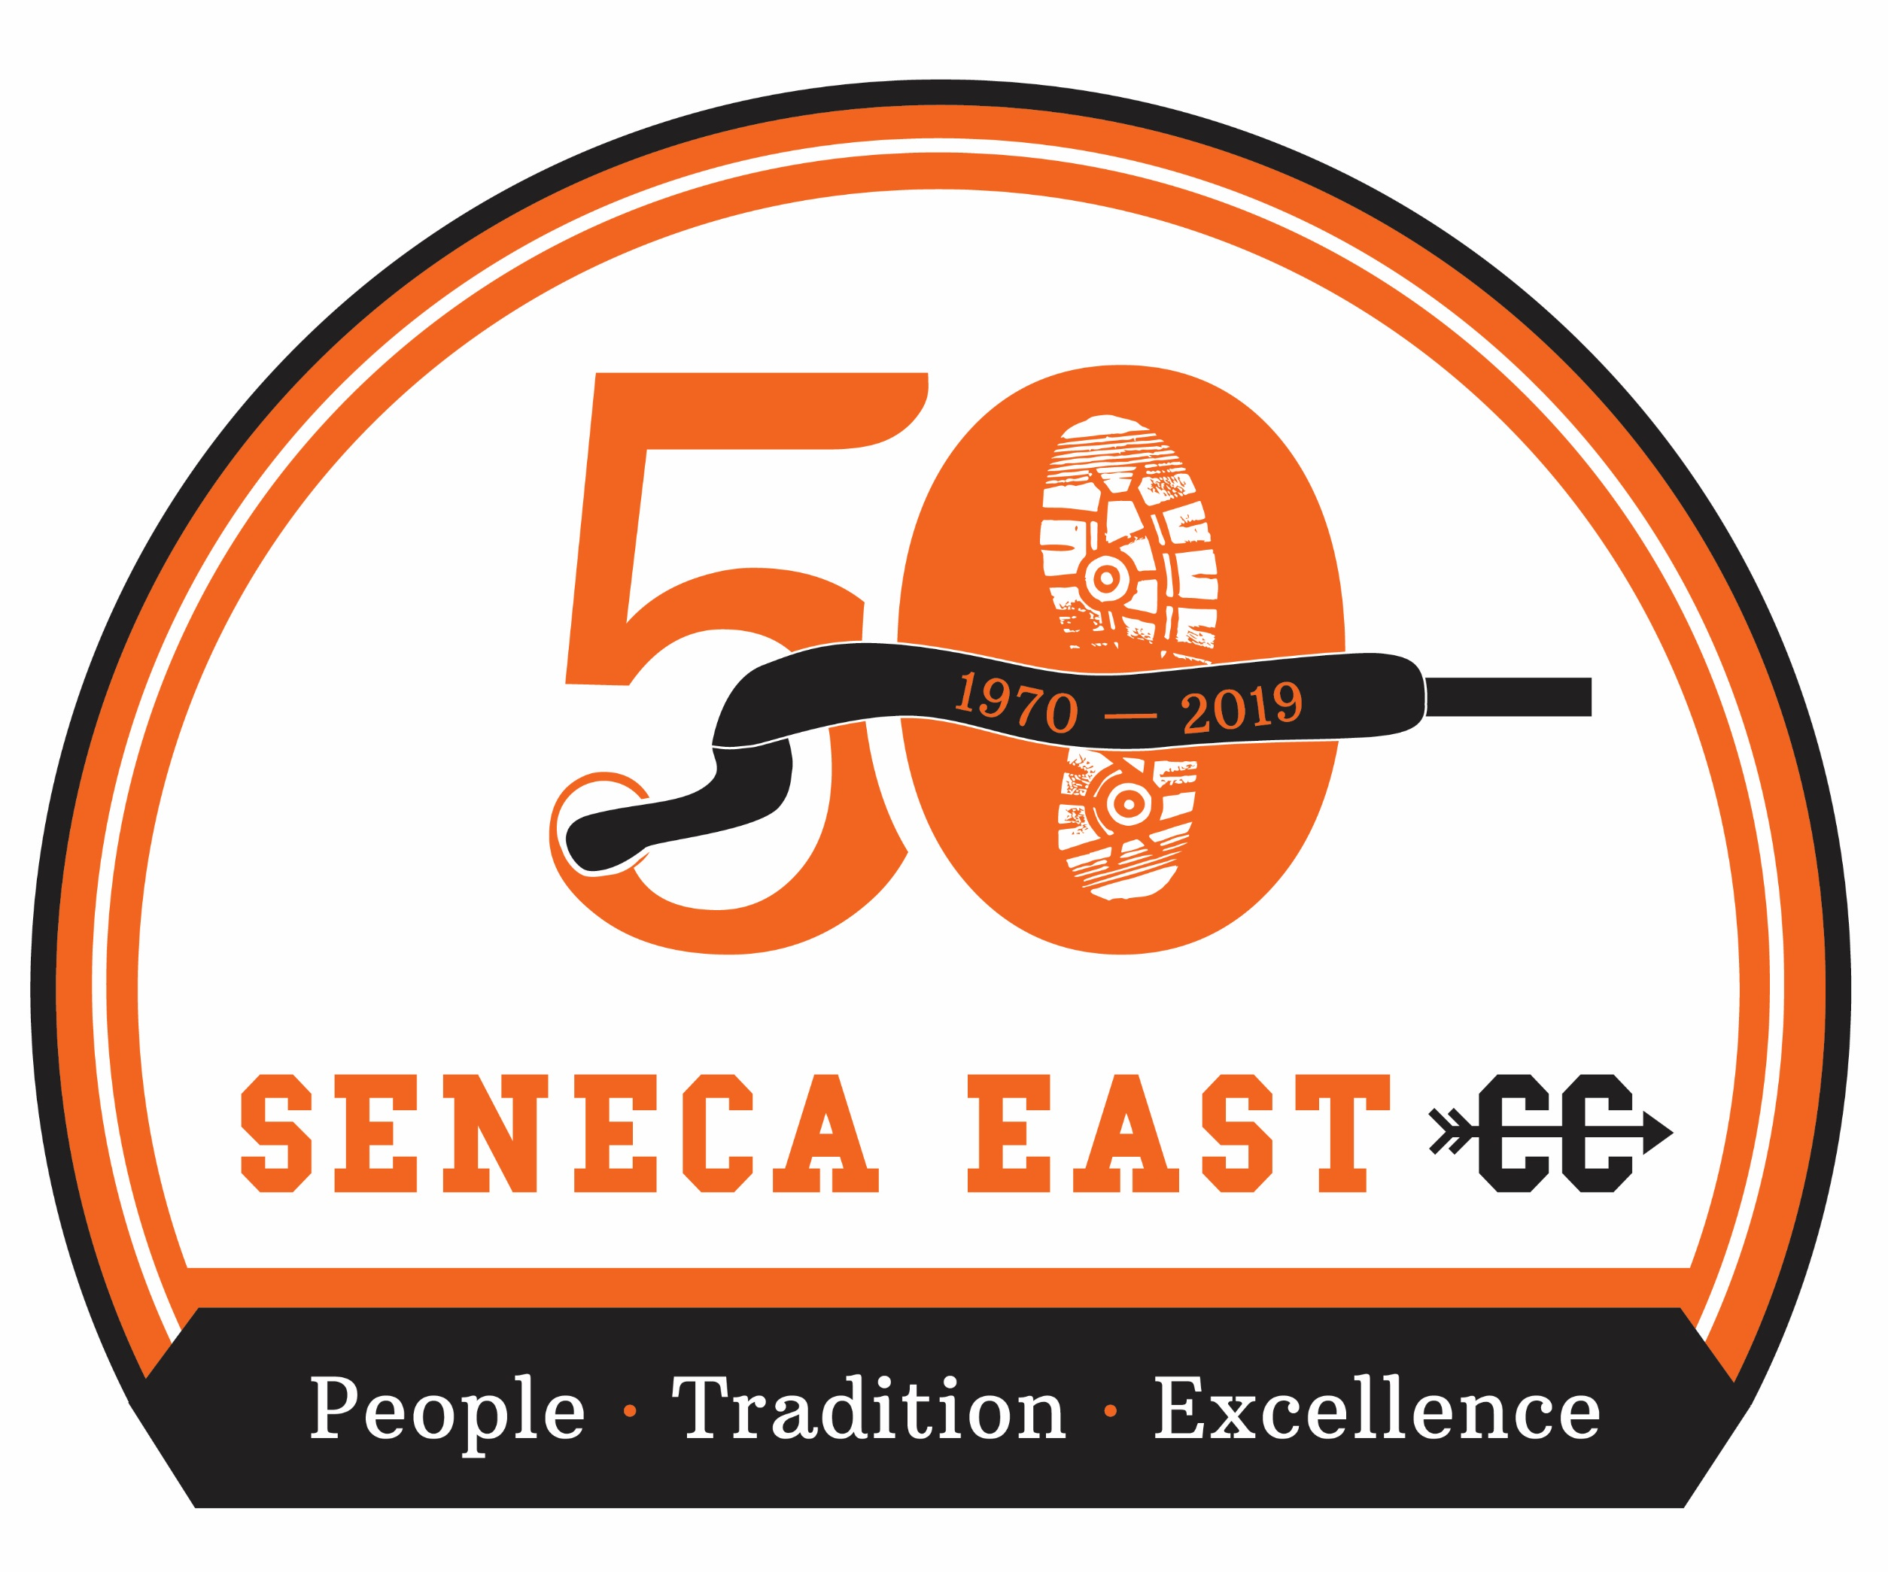

**“PEOPLE”**

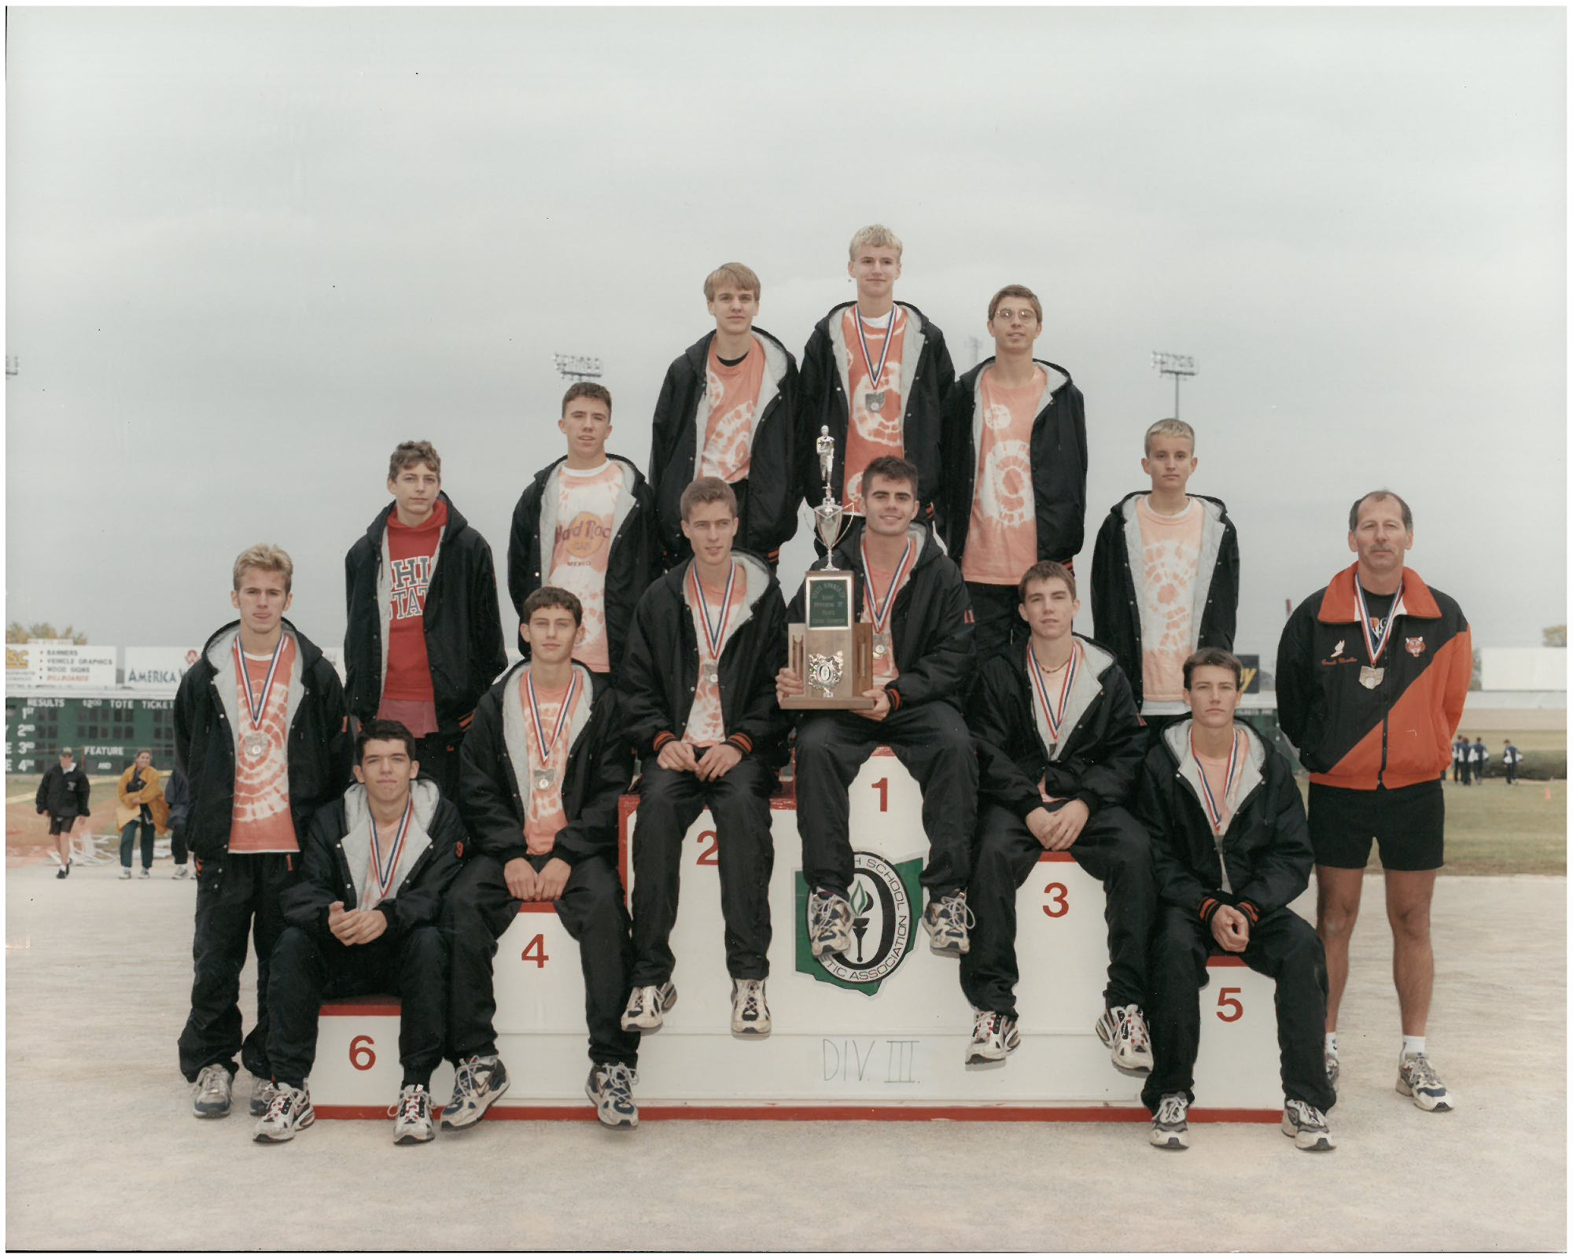

**Seneca East Cross Country**

***Alumni Newsletter Pre-Season 2019***

**“EXCELLENCE”**

